Bigrams Processing with MapReduce and Hadoop

Khai Nguyen

khainguyen@temple.edu

CIS 4517 Data Intensive and Cloud Computing

**(50 points) Part 1: MapReduce**

Count bigrams: Take the word count from the previous problem and extend it to count bigrams. bigrams are sequences of two consecutive words. (Recall our lecture on shingles.) Don't worry about doing anything fancy in terms of tokenization. You can use Java's StringTokenizer.

Deliverables (on Pride and Prejudice):

**1. (10 points) How many unique bigrams are there?**

View number of words OR number of lines since each line is designated for 1 word:

$ find /c /v "" "./output/combined.txt"

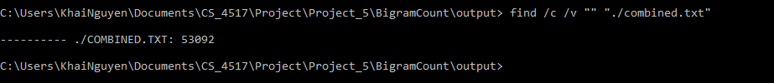

Give 3 examples of such bigrams.

Grabbing data starting at a random line, for example line 20330

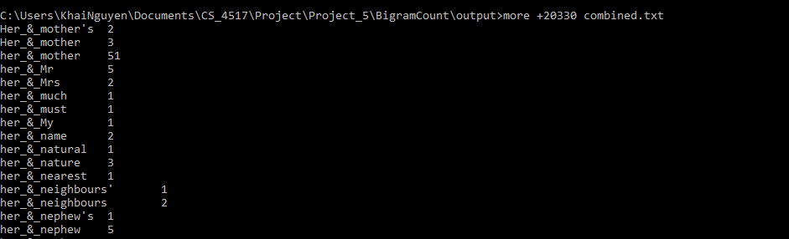

**2. (5 points) List the top ten most frequent bigrams and their counts.**

Using pandas, we can import our recently generated output file, “combined.txt” into a dataframe. Then we can sort by the number of appearances of the bigrams. **Here, 2 bigrams are connected with a “_&_” string.**

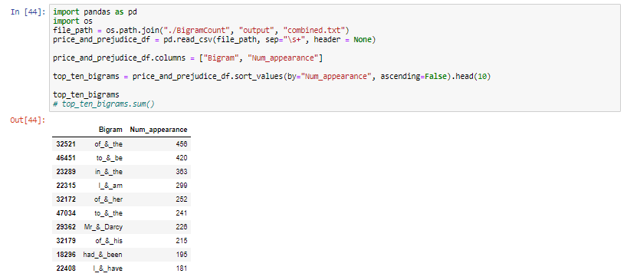

**3. (10 points) What fraction of all bigrams occurrences does the top ten bigrams account for? That is, what is the cumulative frequency of the top ten bigrams?**

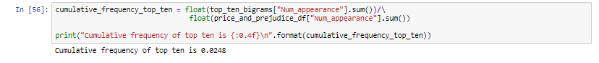

**4. (5 points) How many bigrams appear only once?**



**Give 3 examples of bigrams that appear only once.**

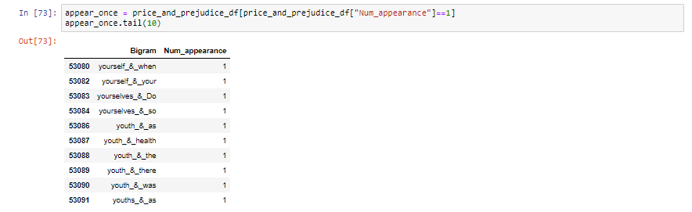

**5. (10 points) What are the five most frequent words following the word "light"? What is the frequency of observing each word?**

From below, we can tell that the 5 most frequent words are *in, A, and, as, began*

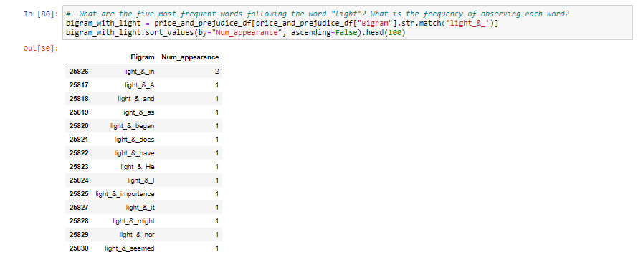

**6. (10 points) Running in the cloud.**

1. **Setup S3** 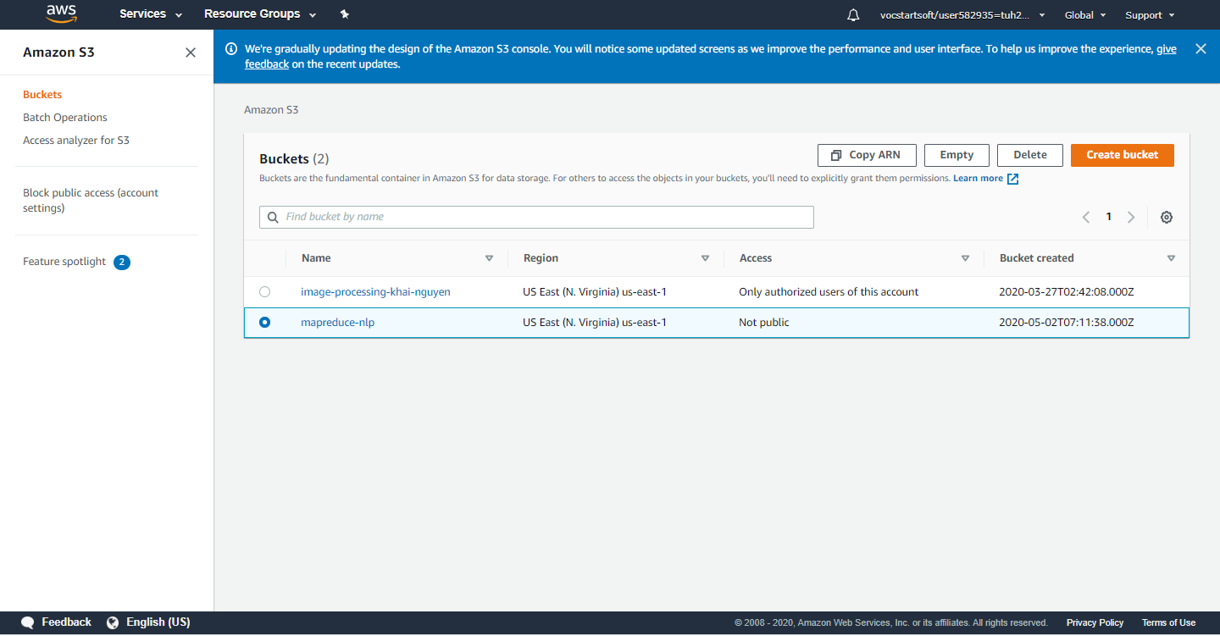

Upload the *document to be processed* and *the executable*

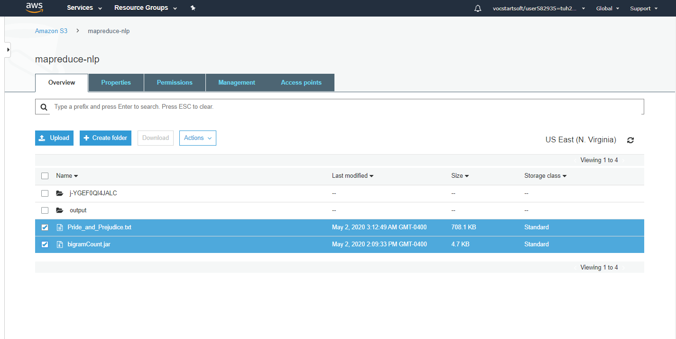

1. **Setup EMR - Amazon Elastic MapReduce**

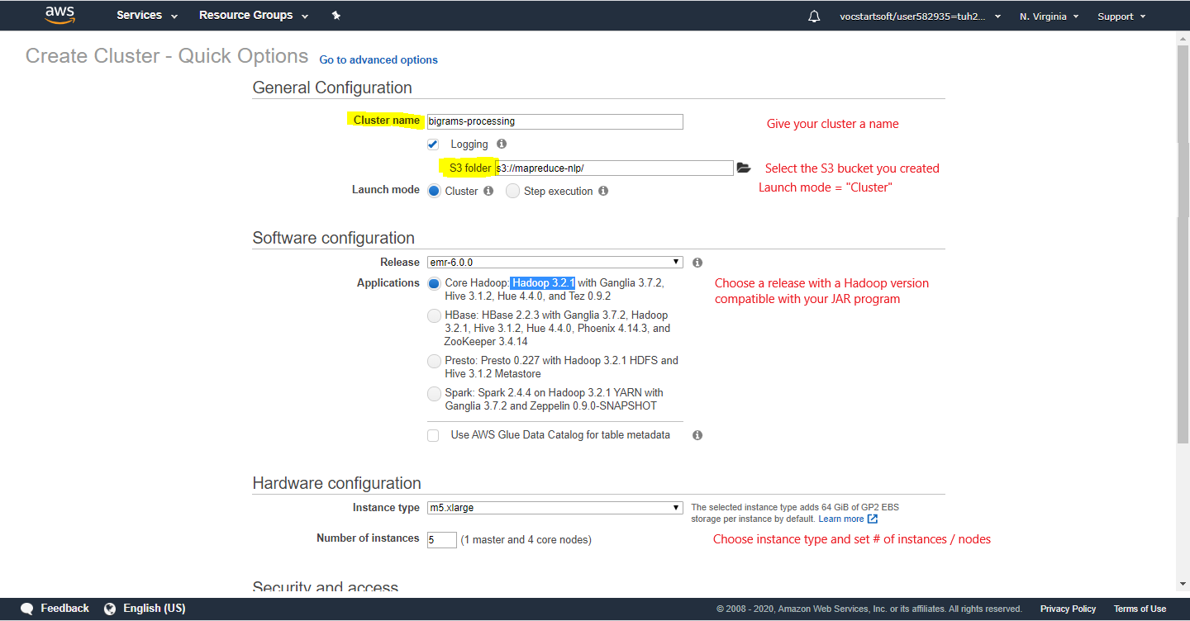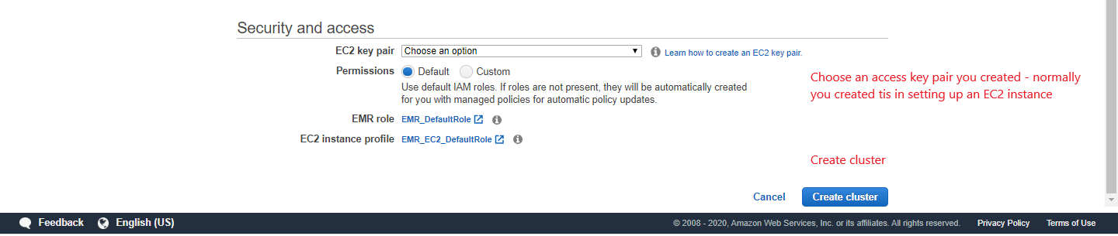

1. **Create a MapReduce job OR *Step* in the EMR cluster** 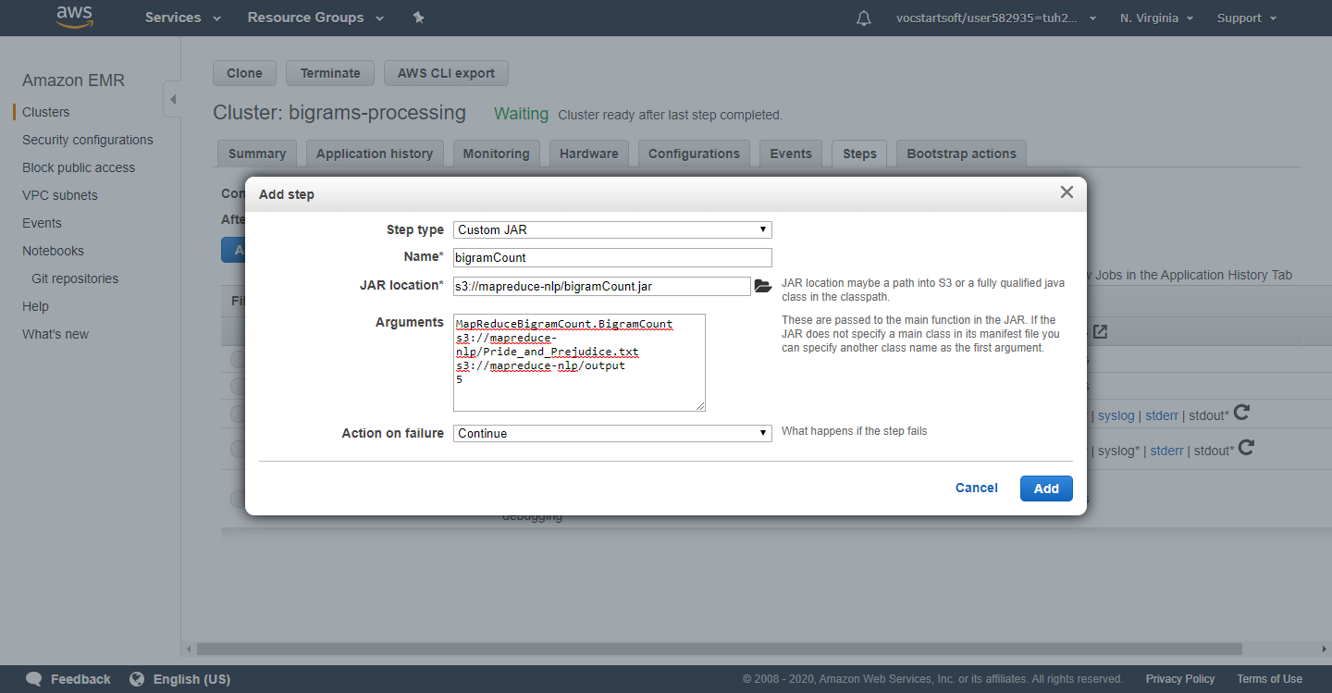
2. **Go back to the S3 console to check the result**

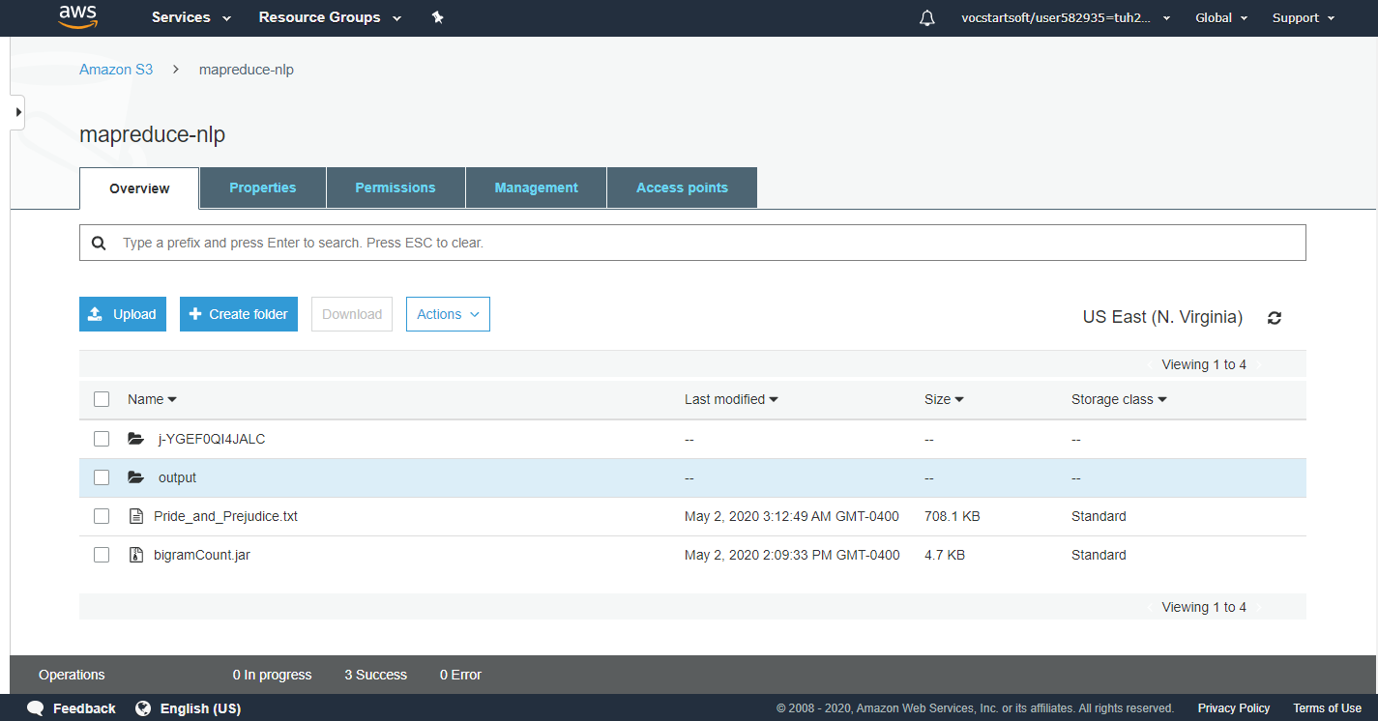

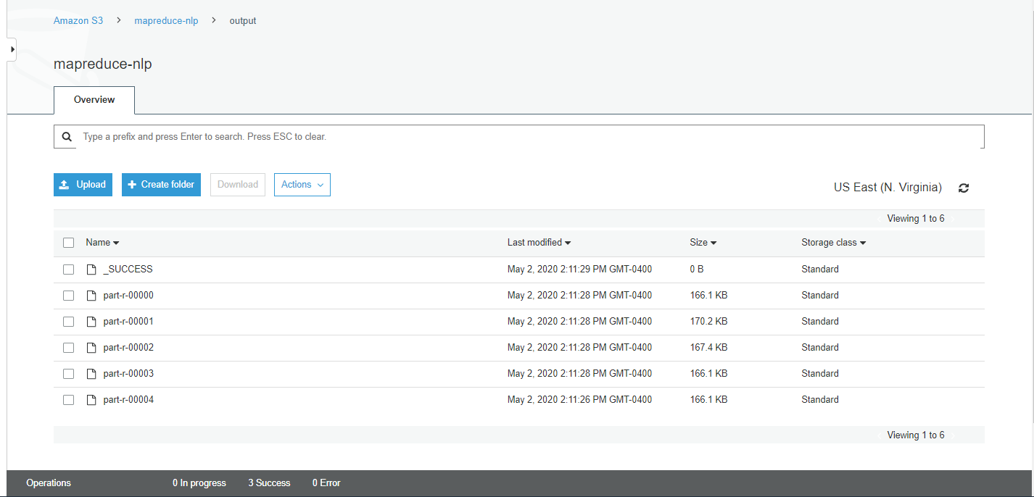

1. **Download the files to your machine**

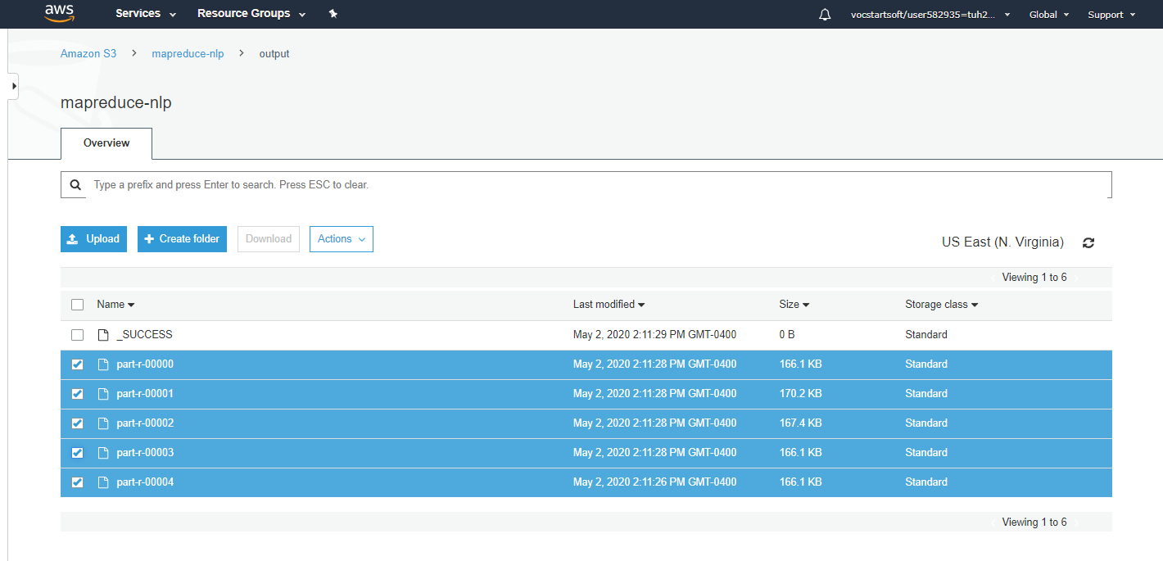

On machine:

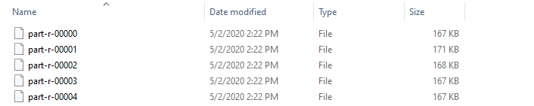

1. **Combine and sort**

$ copy part-r-* temp_combined.txt

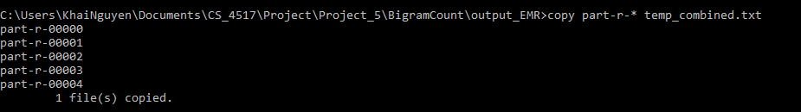

$ sort temp_combined.txt > combined.txt



1. **Check the result**

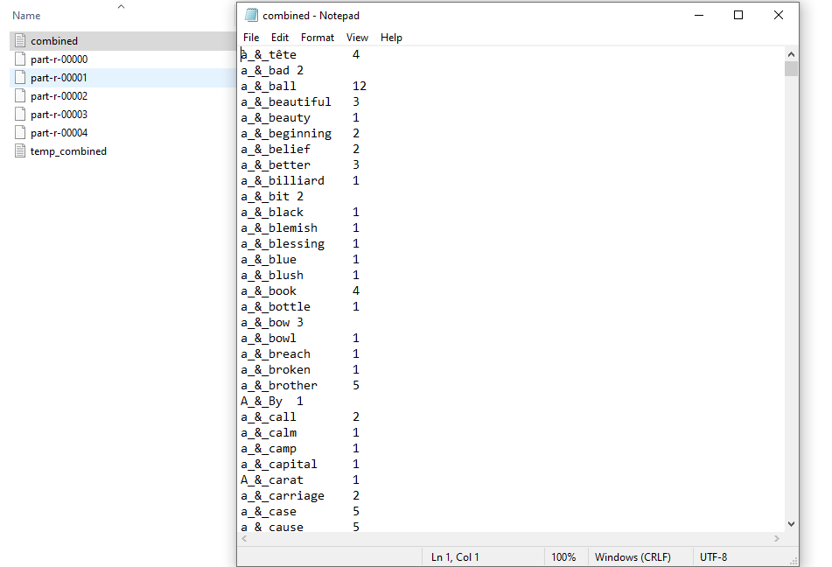

**(50 points) Part 2: Pandas**

For this problem use the data crawled from your Project 2.

**1. (5 points) Describe the that you use to solve this problem. (Hint: get it from your report.)**

BeautifulSoup4 : <https://pypi.org/project/beautifulsoup4/>

python tika : <https://pypi.org/project/tika/>

Pandas: <https://pypi.org/project/pandas/>

IDE:  VSCode and Jupyter Notebook

**2. (5 points) Import the Pandas package.**

$ pip3 install pandas

**3. (5 points) Load data into separate Data Frames. (All of you have collected multiple files. Work with at least 2 files for this problem.)**

a. Use csv functions to load data from csv files if your data is in csv.

b. Use json functions to load data from json documents if your data is in json.

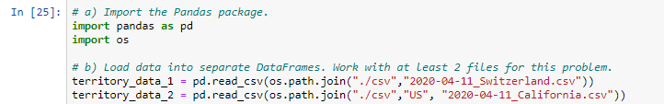

**4. (5 points) Check the data-type of each of column by outputting the dttypes attribute of your DataFrame.**



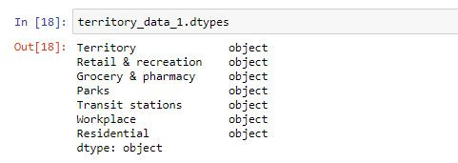

**5. (5 points) Show an example of sorting one of your DataFrames by a column. Give the top-15 entries in descending order.**

Here we sort by the “Parks” column

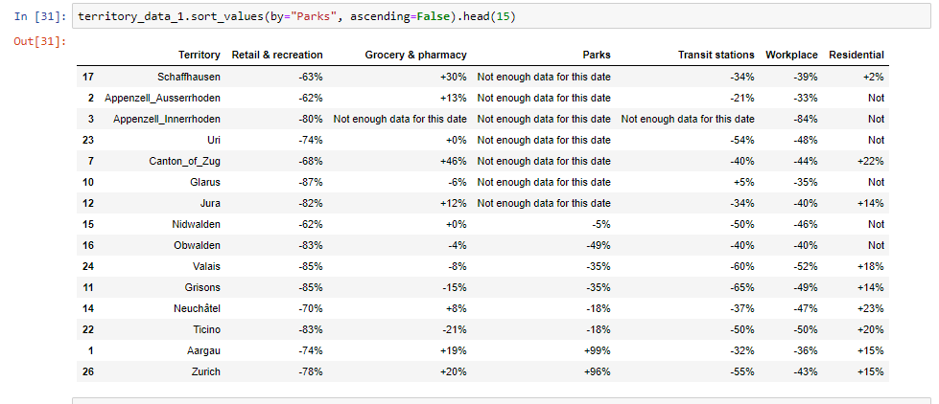

**6. (10 point) Give an example of using filtering.**

a. Give an example for vertical filtering/slicing where you select a subset of the

columns. This corresponds to a projection in a SELECT statement.

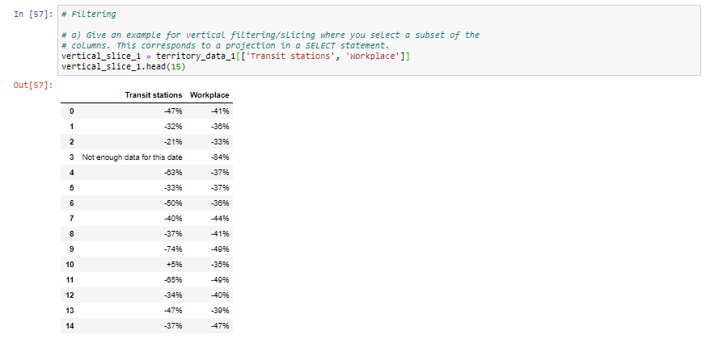

b. Give an example for **horizontal filtering/slicing** where you select a subset of the

rows in your DataFramer according to some criteria. This corresponds to WHERE

in SELECT statement.

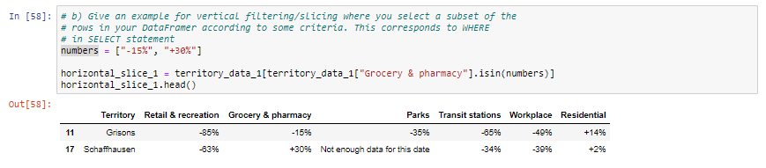

7. (10 points) Show an example where you **merge two DataFrames**.

Perform a concat()

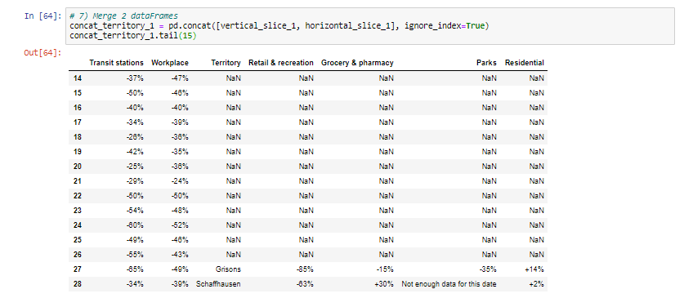

Perform a join(), left_join() in particular:

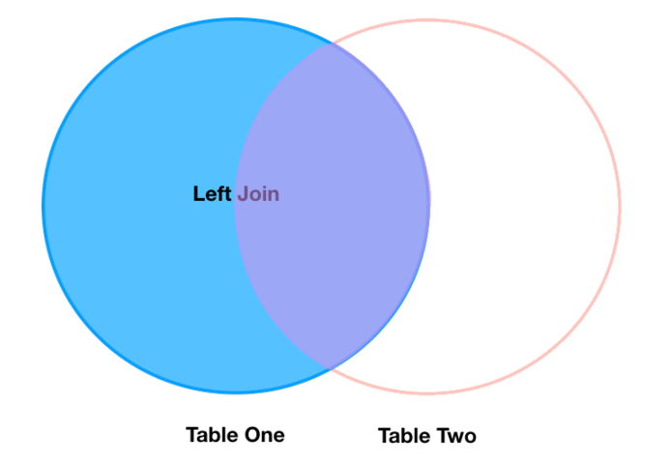

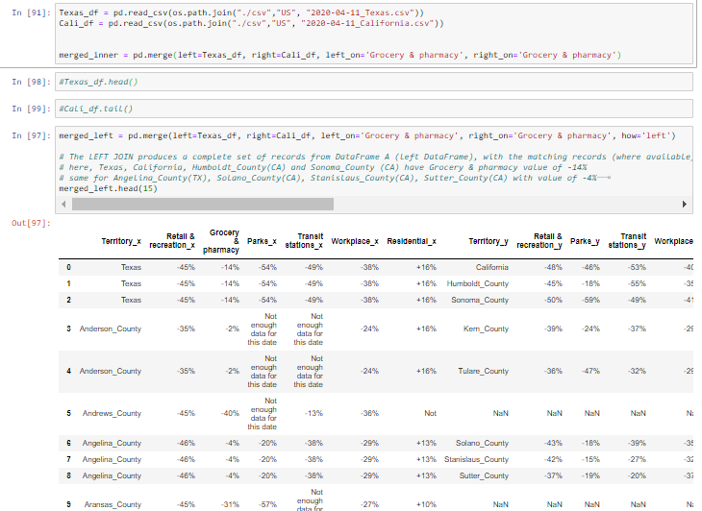

8. (5 points) Export the merged DataFrame to

a. A csv file if your input data is in json documents.

b. **A json file** if your **input data is in csv files.**



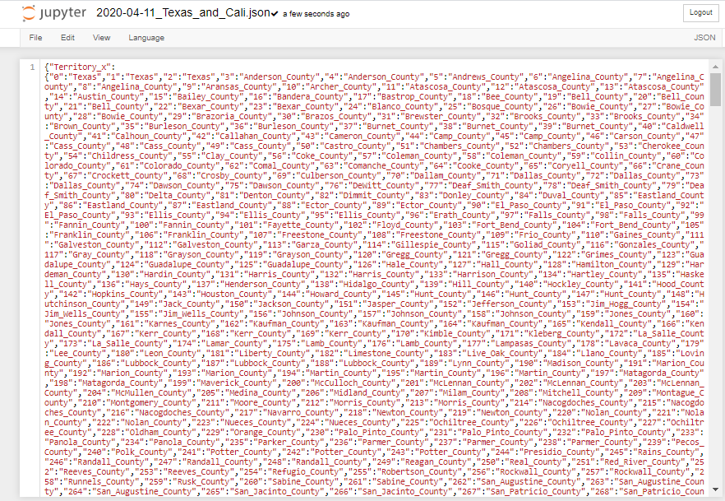

Deliverables:

**• A report that details your solutions.**

**• Include screen captures for every step of your solutions to convincingly show that**

**o You have a working solution.**

**o You are able to execute your implementations of the solutions.**

• Upload the source code (exclude packages or libraries you might have used) in

canvas.

• Give a ReadMe file where you describe how one can run your code.